**Skrypnyk, Leonid (Скрипник, Леонід) (1893-1929)**

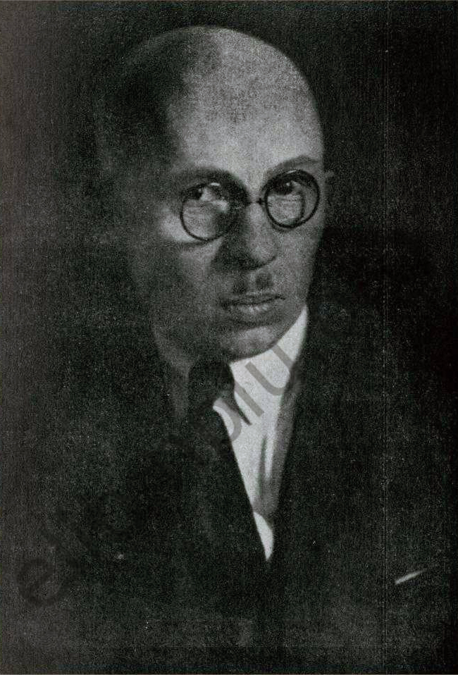

Major Ukrainian futurist prose writer, literary and cultural theoretician, photographer, a close collaborator of Mykhail' SEMENKO and the FUTURIST journal *Nova generatsiia* (NEW GENERATION, 1927-1930). He died prematurely from tuberculosis. Skrypnyk came to literature and art with an engineering and aviation background, having also worked in the Ukrainian film industry, bringing a rational, analytical and anti-sentimental attitude to his writings. He published on photography, film, and cultural theory, contributing to the theory of Panfuturism. Skrypnyk's prose legacy is small but important, consisting of a novel, a short story and two fragments from an incomplete novel. His major work—*The Intellectual. A Screened Novel in Six parts with a Prologue and Epilogue*—was a hybrid, so-called, “destructive” genre combining a screenplay and novel, complemented by “authorial” comments, and printed with visual typographic effects. *The Intellectual* is a cerebral dissection of “bourgeois” mores as they reemerged in the post-revolutionary period. In his cultural theory Skrypnyk took the radical futurist position that most traditional arts were antiquated and should be destroyed or changed through experimentation. Some of his works appeared under the pseudonyms “M. Lans'kyi” and “Levon Lain.”

**References and Further Reading**:

Elliott, Kamilla. (2003) *Rethinking the Novel/Film Debate*. Cambridge, United Kingdom: Cambridge University Press, 83.

Ilnytzkyj, Oleh S. (2013). “Under Imperial Eyes: Ukrainian Modernist and Avant-Garde Publications.” Editors Peter Brooker, Sascha Bru, Andrew Thacker and Christian Weikop. *Modernist Magazines: A Critical and Cultural History. Volume 3, Part II: Europe 1880-1940.* Oxford: Oxford University Press, 1341-1362.

Ilnytzkyj, Oleh S. (1997). *Ukrainian Futurism: A Historical and Critical Study*. Cambridge/MA: Harvard University Press; Ukrainian Research Institute.

Nebesio, Bohdan Y. "The Theoretical Past Of Cinema: Introducing Ukrainian Film Theory Of The 1920S." *Film Criticism* 20 (1995): 67-77.

Nebesio, Bohdan Y. “Panfuturists and the Ukrainian Film Culture of the 1920s,” KinoKultura < http://www.kinokultura.com/specials/9/nebesio.shtml>

“Skrypnyk, Leonid.” *Nova generatsiia* 3 (1929): 5.

“Skrypnyk, Leonid.” *Krytyka* 3 (1929): 125.

**Major works**:

*Poradnyk fotohrafa* [Photographer’s Guide]. Kharkiv: DVU, 1927.

*Narysy z teoriï mystetstva kino*. [Essays in the Theory of Cinema] Kharkiv: DVU, 1929.

*Intelihent. Ekranizovanyi roman na shist' chastyn z prolohom ta epilohom*. [*The Intellectual. A Screened Novel in Six part with a Prologue and Epilogue*] Kharkiv: Proletarii, 1929.

“Ivan Petrovych i Felis.” [Ivan Petrovych and Phyllis. From the novel “Episodes from the Life of a Strange Person”] *Chervonyi shliakh* 11 (1928): 7–31.

“Materiialy do biohrafiï pys'mennyka Loputs'ky.” [Materials Toward a Biography of the Writer Loputs'ka] *Nova generatsiia* 11 (1928): 293–303.

“Pershe kokhannia Ivana Petrovycha. Z romanu ‘Epizody z zhyttia chudnoi liudyny’” [Ivan Petrovych’s First Love. From the novel “Episodes from the Life of a Strange Person”] *Zhyttia i revoliutsiia* 10 (1928): 39–42.

“Livyi roman.” [The Left Novel] *Nova generatsiia* 2 (1927): 34–38. [Under the pseudonym M. Lans'kyi]

“Teatr, tsyrk, opera, tanok, muzyka.” [Theatre, Circus, Opera, Dance Music] *Nova generatsiia* 4 (1929): 41–50.

“Literatura.” [Literature] *Nova generatsiia* 5 (1929): 34–40.

“Poeziia.” [Poetry] *Nova generatsiia* 9 (1929): 17–22.

“Asotsiial'ni i sotsiial'ni mystetstva.” *Nova generatsiia* 11 (1929): 26–33.

“Mystetstva sotsiial'ni i asotsiial'ni.” [Social and Asocial Arts] *Nova generatsiia* 12 (1929): 25–29.

**Oleh S. Ilnytzkyj, University of Alberta**

**Source url for image:**

**Nova generatsiia, no. 3, 1929**

<http://elib.nplu.org/view.html?id=1134>